**Data Analyst Assignment: Customer & Operations Analysis**

**Prepared By:** Sharmila Dwarapureddy

**Submission Date:** 20-02-2025

**📝 1. Introduction**

* **Purpose:** Analyse customer behaviour, inventory, and discount impact for an online grocery business.
* **Data Sources:** Sales data, inventory data, discount campaign data, user orders.
* **Tools Used:** Python, Excel, SQL.

**📎 2. Appendix**

* **References** to data sources (orders.csv, inventory.csv, discount_campaign.csv).
* **Tools Used:** Python (Pandas, Seaborn, Matplotlib, Sklearn), Excel, SQL (SQLite).

**📊 3. Python Analysis**

**A. Customer Segmentation (K-Means Clustering)**

**Objective:**

Segment customers based on their spending, order frequency, and recency.

**Key Steps:**

* Aggregated customer metrics: **Total Spend, Order Count, Recency (days since last order)**.
* Scaled data using **StandardScaler**.
* Applied **K-Means Clustering (k=3)** to group customers.
* Visualized the clusters using a **scatter plot (Total Spend vs. Order Count)**.
* Visualized the clusters using a **scatter plot (Recency vs. Total Spend)**
* Visualized Line chart of **Monthly Revenue Trend**

**Key Insight:**

* Cluster 1: **High Spend, Frequent Orders (Loyal Customers)**.
* Cluster 2: **Moderate Spend, Occasional Orders**.
* Cluster 3: **Low Spend, Infrequent Orders**.

**Sample code:**

# Apply K-Means clustering (e.g., 3 clusters)

k = 3

kmeans = KMeans(n_clusters=k, random_state=42)

customer_metrics['cluster'] = kmeans.fit_predict(scaled_features)

# Check cluster distribution

print(customer_metrics['cluster'].value_counts())

# Visualize clusters: Total Spend vs. Order Count

plt.figure(figsize=(10, 6))

sns.scatterplot(

x='total_spend',

y='order_count',

hue='cluster',

data=customer_metrics,

palette='viridis'

)

plt.title('Customer Segmentation: Total Spend vs. Order Count')

plt.xlabel('Total Spend')

plt.ylabel('Order Count')

plt.show()

# Convert order_date to Period and then to Timestamp

orders['order_month'] = orders['order_date'].dt.to_period('M')

orders['order_month'] = orders['order_month'].dt.to_timestamp()

# Aggregate revenue by month

monthly_revenue = orders.groupby('order_month')['total_amount'].sum().reset_index()

plt.figure(figsize=(10, 6))

sns.lineplot(x='order_month', y='total_amount', data=monthly_revenue, marker='o')

plt.title('Monthly Revenue Trend')

plt.xlabel('Month')

plt.ylabel('Total Revenue')

plt.xticks(rotation=45)

plt.show()

# Extract the day of the week from order_date

orders['order_day'] = orders['order_date'].dt.day_name()

daily_orders = orders['order_day'].value_counts().reset_index()

daily_orders.columns = ['day', 'order_count']

print(daily_orders)

plt.figure(figsize=(8, 5))

sns.barplot(x='day', y='order_count', data=daily_orders, hue='day', palette='coolwarm')

plt.title('Orders by Day of the Week')

plt.xlabel('Day of the Week')

plt.ylabel('Number of Orders')

plt.legend([],[], frameon=False) # This removes the legend

plt.show()

#visualise cluster: Recency vs. Total Spend

plt.figure(figsize=(10, 6))

sns.scatterplot(

x='recency',

y='total_spend',

hue='cluster',

data=customer_metrics,

palette='plasma'

)

plt.title('Customer Segmentation: Recency vs. Total Spend')

plt.xlabel('Recency (Days Since Last Order)')

plt.ylabel('Total Spend')

plt.show()

**Visualization:**

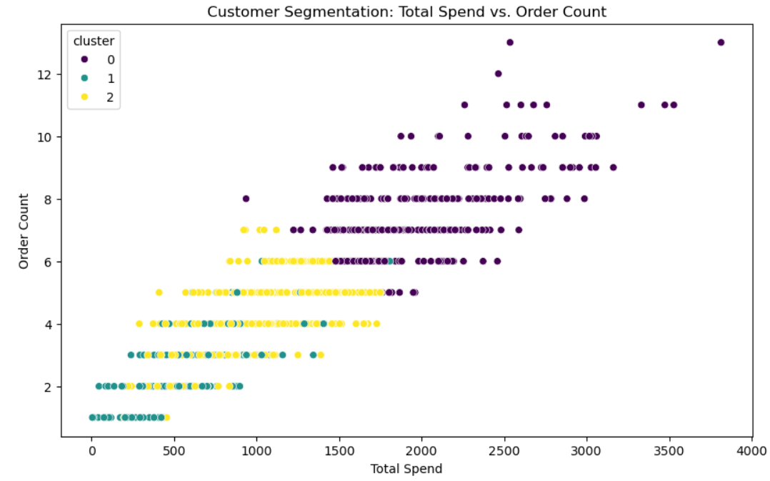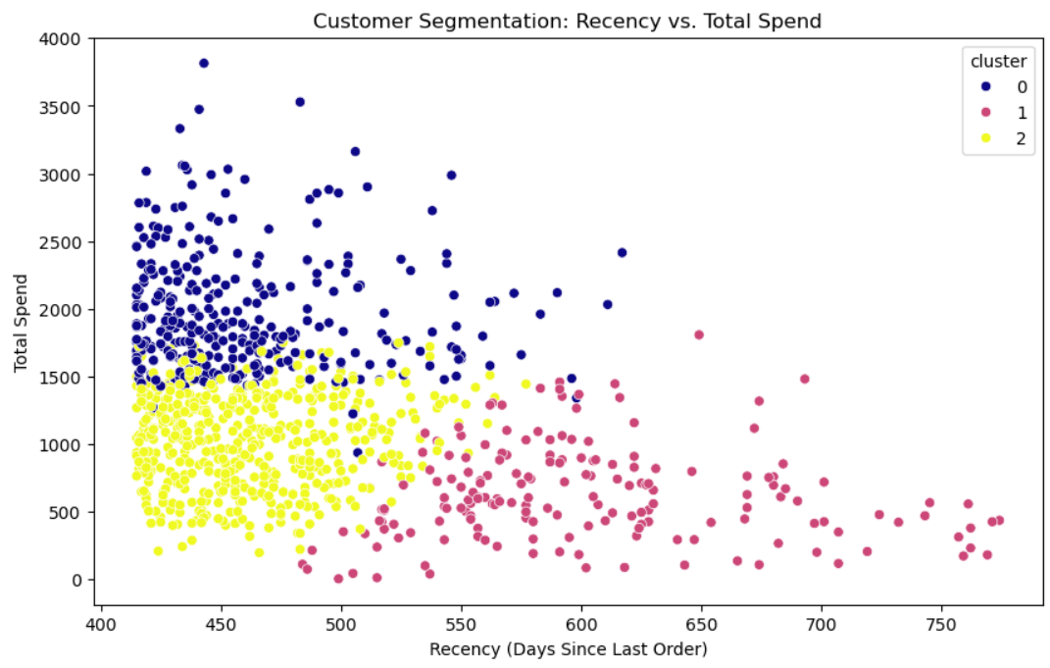

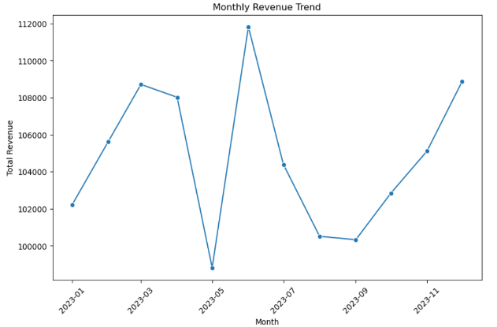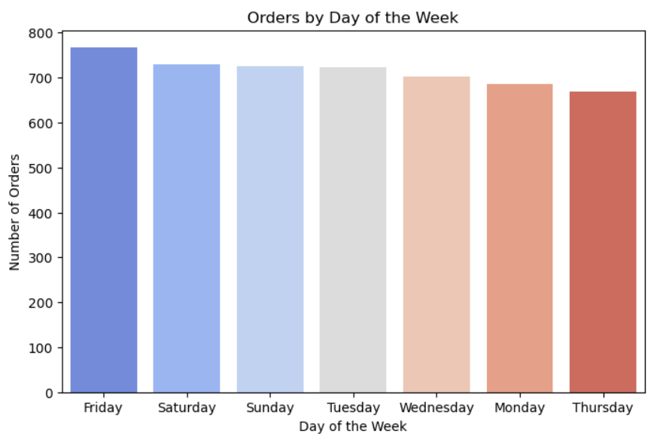

**B. Discount Impact Analysis**

**Objective:**

Analyze the effect of discounts on customer behavior.

**Key Steps:**

* Compared **order count and total spend** before and after applying a discount.
* Segmented customers into **Discount Applied (Yes/No)** groups.
* Visualized the difference in **spending behavior**.

**Key Insight:**

* Customers **who received discounts** showed **an increase in spending and order frequency**.
* Customers **without discounts** showed **a stable or slight decrease** in spending.

**Sample Code:**

# Set up a figure with two subplots side-by-side

fig, axes = plt.subplots(1, 2, figsize=(14, 6))

# Plot average percentage change in order count

summary['order_count_change_pct'].plot(kind='bar', ax=axes[0], color=['skyblue', 'salmon'])

axes[0].set_title("Average % Change in Order Count")

axes[0].set_xlabel("Discount Applied")

axes[0].set_ylabel("Average % Change")

axes[0].set_ylim([min(summary['order_count_change_pct'])-10, max(summary['order_count_change_pct'])+10])

# Plot average percentage change in total spend

summary['spend_change_pct'].plot(kind='bar', ax=axes[1], color=['skyblue', 'salmon'])

axes[1].set_title("Average % Change in Total Spend")

axes[1].set_xlabel("Discount Applied")

axes[1].set_ylabel("Average % Change")

axes[1].set_ylim([min(summary['spend_change_pct'])-10, max(summary['spend_change_pct'])+10])

plt.tight_layout()

plt.show()

**Visualization:**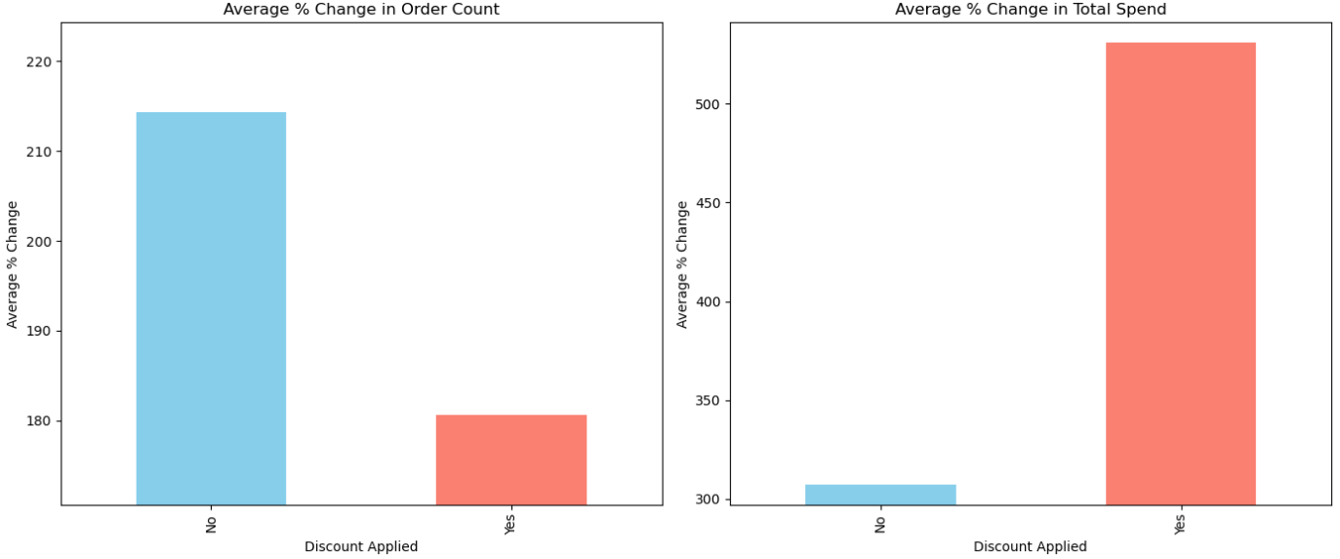

**📈 4. Excel Analysis**

**A. Inventory Performance Analysis**

**Key Analysis:**

* **Stock Level Overview:** Identified products with low stock.
* **Out-of-Stock Status:** Created a **Pie Chart** showing **Yes/No** status.
* **Inventory Value:** Suggested adding **Unit Price column** to calculate **Stock Level * Unit Price**.

**Key Insight:**

* **Frequent Out-of-Stock Products:** Need better inventory planning.
* **Low Stock Products:** Require restocking.

**Visualizations:**

**B. Sales Trend Analysis**

**Key Analysis:**

1. **Monthly Revenue Trend:** Line chart showing revenue pattern over time.
2. **Daily Orders:** Bar chart showing order distribution by day.
3. **Regional Sales:** Pivot table analysis of revenue across regions.

**Key Insight:**

* **Seasonal Trends:** Peak sales in certain months.
* **Best-Performing Region:** Identified based on revenue.

**Visualizations:**

**Table***:*

|  |  |
| --- | --- |
| **Row Labels** | **Sum of total_revenue** |
| Jan | ₹ 1,02,152.91 |
| Feb | ₹ 1,09,304.17 |
| Mar | ₹ 1,03,387.82 |
| Apr | ₹ 1,02,659.68 |
| May | ₹ 1,03,633.13 |
| Jun | ₹ 1,01,293.64 |
| Jul | ₹ 1,14,113.43 |
| Aug | ₹ 97,395.46 |
| Sep | ₹ 1,07,841.21 |
| Oct | ₹ 1,15,082.64 |
| Nov | ₹ 1,02,224.75 |
| Dec | ₹ 1,03,771.55 |
| **Grand Total** | **₹ 12,62,860.39** |

**Table**:

|  |  |
| --- | --- |
| **Row Labels** | **Sum of total_revenue** |
| Fruits | ₹ 1,92,956.76 |
| Chicken | ₹ 1,87,973.58 |
| Bread | ₹ 1,85,681.73 |
| Rice | ₹ 1,82,133.30 |
| Eggs | ₹ 1,73,621.45 |
| Vegetables | ₹ 1,70,379.17 |
| Milk | ₹ 1,70,114.40 |
| **Grand Total** | **₹ 12,62,860.39** |

**Table:**

|  |  |
| --- | --- |
| **Row Labels** | **Sum of total_revenue** |
| Central | ₹ 2,43,508.68 |
| East | ₹ 2,63,080.64 |
| North | ₹ 2,65,056.72 |
| South | ₹ 2,48,066.92 |
| West | ₹ 2,43,147.43 |
| **Grand Total** | **₹ 12,62,860.39** |

**🧑‍💻 5. SQL Analysis**

**Objective**

The goal of this analysis is to evaluate customer retention, purchasing trends, and delivery performance. Insights from this data can help the business improve customer engagement and delivery operations.

**A. Identify Consecutive orders Customers 60 Days ago**

**Approach:**

1. Identify customers with at least 2 past orders.
2. Find the last order date for each customer.
3. Filter customers whose last order was more than 60 days ago.

**SQL Query**: max_orders.sql

SELECT field2 AS customer_id,

MAX(field3) AS last_order_date,

COUNT(field1) AS order_count

FROM orders1

GROUP BY field2

HAVING MAX(field3) < date('now', '-60 days')

AND COUNT(field1) >= 2;

**Output Sample:**

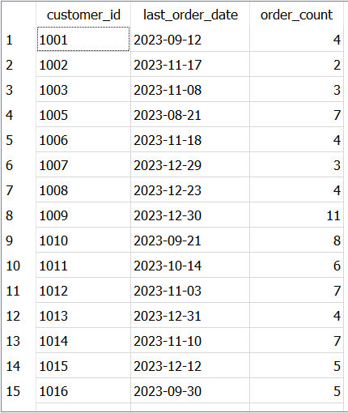

**Insights:**

* These customers were once active but have not ordered recently.
* Re-engagement campaigns (emails, discounts) can win back their business.

**B. Average Time Between Consecutive Orders for Customers**

**Approach:**

1. Focus on customers with more than one order.
2. Calculate the date difference between consecutive orders for each customer.
3. Compute the average time between orders.

**SQL Query:**

WITH order_diffs AS (

SELECT

field2 AS customer_id,

field3 AS order_date,

julianday(field3) - julianday(LAG(field3) OVER (PARTITION BY field2 ORDER BY field3)) AS diff_days

FROM orders1

)

SELECT

customer_id,

AVG(diff_days) AS avg_days_between_orders

FROM order_diffs

WHERE diff_days IS NOT NULL

GROUP BY customer_id;

**Output Sample:**

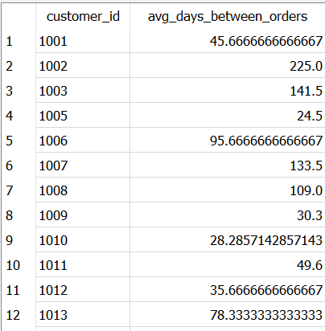

**Insights:**

* Helps forecast future orders and manage stock levels.
* Identifying drops in frequency may signal customer disengagement.

**C. Top 10% Customers by Total Spend & Their Average Order Value**

**Approach:**

1. Sum the total spending per customer.
2. Identify the top 10% of customers by spending.
3. Calculate their average order value.

**SQL Query:**

WITH customer_spend AS (

SELECT

field2 AS customer_id,

SUM(field5) AS total_spend,

COUNT(field1) AS order_count

FROM orders1

GROUP BY field2

),

percentile_threshold AS (

SELECT

total_spend

FROM customer_spend

ORDER BY total_spend DESC

LIMIT 1 OFFSET (SELECT CAST(0.9 * COUNT(*) AS INT) FROM customer_spend) - 1

)

SELECT

customer_id,

total_spend,

order_count,

ROUND(total_spend * 1.0 / order_count, 2) AS avg_order_value

FROM customer_spend

WHERE total_spend >= (SELECT total_spend FROM percentile_threshold)

**Output Sample:**

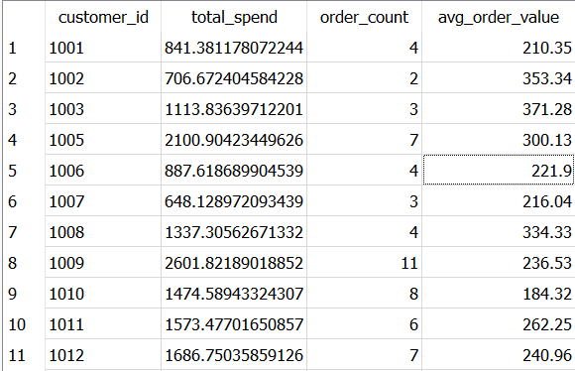

**Insights**:

* High-value customers drive a large portion of revenue.
* Special loyalty programs or personalized discounts can ensure retention.

**D. Analyse Delivery Time Efficiency**

**Approach:**

1. Join orders1 and delivery_performance on order_id.
2. Calculate the percentage of on-time deliveries for each city (region).

**SQL Query:**

SELECT

o.field4 AS region,

ROUND(

100.0 * SUM(CASE WHEN TRIM(UPPER(d.field3)) = 'ON TIME' THEN 1 ELSE 0 END)

/ COUNT(*), 2

) AS on_time_delivery_percentage

FROM orders1 o

JOIN delivery_performance d ON o.field1 = d.field1

GROUP BY o.field4;

**Output Sample:**

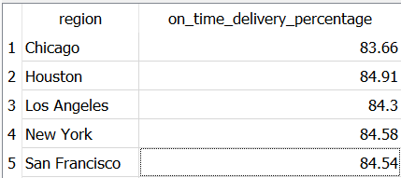

**Insights:**

* Some regions consistently meet delivery times; others need improvement.
* Delays can damage customer satisfaction and lead to churn.
* Focus on improving logistics in underperforming regions.

**Key Findings Summary:**

|  |  |  |
| --- | --- | --- |
| Task | Key Insight | Business Implication |
| Inactive Customers | Certain customers have not ordered in 60+ days. | Target them with re-engagement campaigns. |
| Order Frequency | Repeat customers show ordering patterns. | Use patterns for demand forecasting and personalized offers. |
| High-Value Customers | Top 10% contribute significantly to revenue. | Prioritize loyalty and retention strategies for them. |
| Delivery Performance | Delivery efficiency varies by region. | Improve operations in low-performing regions. |

**Business Implications (Overall):**

* Proactively re-engage inactive customers to reduce churn.
* Focus on retaining high-value customers with loyalty programs.
* Leverage order frequency patterns to optimize stock and marketing.
* Address delivery inefficiencies in specific regions to boost customer satisfaction.

**✅ 6. Key Recommendations**

* **Customer Segmentation:** Develop **targeted marketing** for **high-value customers**.
* **Discount Campaigns:** Offer **personalized discounts** to **boost spending**.
* **Inventory Management:** Improve **stock forecasting** to **reduce out-of-stock issues**.
* **Sales Strategy:** Focus on **high-performing regions** for **promotional campaigns**.